Venn Diagrams and Beads
Subject: Mathematics Creator: Alison Kimbley
Strand: Patterns and Relations Grade: 4
Content (topic)

Exploring Venn Diagrams with Manipulatives
Outcomes  P 4.1: Demonstrate an understanding of patterns and relations by:  - Identifying and describing patterns in a chart, table or diagram  - Reproducing patterns and relations in a chart, table, or diagram using manipulatives  - Creating charts, tables, or diagrams to represent patterns and relations  - Solving problems involving patterns and relations | Indicators  P 4.1l: Identify the sorting rule for a Venn diagram  P 4.1m: Describe the relationship shown in a given Venn diagram when the circles intersect, when one circle is contained in the other, and when the circles are separate.  P 4.1n: Determine where new data belong in a Venn diagram.  P4.1o: Solve a problem by using a chart or diagram to identify mathematical relationships
Mathematical Processes
- Connection
- Problem Solving
- Reasoning
- Visualization
- Communication
Lesson Preparation
Equipment/materials:
- Pieces of yarn approximately 50 centimeters (20 inches) in length. Each group of students will need three lengths, each of a different color
- A set of beads for each group of students
- A piece of felt approximately 30 cm by 25 cm (12 inches by 9 inches) for each group of students. Note: Placing the beads on the felt will keep the beads from rolling away.

Advanced Preparation:
- Prepare a large example of a Venn diagram to assist students in understanding the concept of classifying material and choosing critical attributes.
- Prepare pieces of felt or single-colored fabric
- Have a variety of beads set aside in small bags ready for students to classify
- Prepare pieces of yarn about 50 centimeters (20 inches) in length.
Presentation
Development
- Teach the students about the significance of beads. For example, beading has been an important part of First Nations culture for approximately 8 000 years prior to European contact. Beads were made of shell, pearl, bone, teeth, stone, and fossil stems. Glass beads became a part of First Nation and Métis culture when the explorers came from Europe and brought seed and glass beads as trading items.
- Explain to students that each tribe had distinct designs, patterns, and approaches; therefore, collections of First Nations beadwork art includes many different designs, styles, traditions and stitches. In Saskatchewan, the Plains Cree People use a lot of symmetry in their patterns as well as distinctive geometrical shapes.
- Introduce to the students the concept of a Venn diagram using beads and the characteristic of size, shape and color.
- Divide the students into groups of 3 or 4. Give each group 3 lengths of yarn, each of a different color, some beads and a piece of felt.
- Have the students form a loop from each piece of yarn by tying its ends together and spread the beads on the felt. See Appendix A- figure 1.
- Have each group place their piece of felt on a flat level surface and spread the beads on the felt.
- Next, ask the students to form a circle from one of the loops of yarn and place it on the felt. Have each group of students decide on a bead characteristic, a value for that characteristic and place all the beads that satisfy that value inside the circle. Appendix A- figure 2 is characterized by size, the value is large and all large beads are inside the circle.
- Next, ask the students to form a second loop into a circle and place it on the felt partially overlapping the first circle.
- Have each group of students decide on a second bead characteristic, a value for that characteristic and place all the beads that satisfy this value inside the second circle. Appendix A- figure 3 has color as its second characteristic and all the light blue beads are placed inside the second circle. Note: the beads in the overlap of the two circles are large and light blue.
- Finally, ask the students to form the third loop into a circle and place it on the felt partially overlapping the first two circles.
- Have each group of students decide on a third bead characteristic, a value for that characteristic and place all the beads that satisfy this value inside the third circle. Appendix A- figure 4 has shape as its third characteristic and all the round beads are placed inside the third circle.
- Have the students describe the beads that are in various parts of the Venn diagram. For example, the beads inside both the black and pink circles are light blue and round.
- Now, ask the students questions that would require them to solve a problem using the Venn diagram. Such questions could include:
  - How many large beads are round?
  - How many large beads are not round?
- After students have understood the concept of categorizing, the students can play a game in which a student decides on a characteristic such as “sparkles,” but does not tell the other group members the attribute rule. The remaining two group members try to determine the rule in which the beads are sorted. Encourage the students to discuss the process in which the data is collected.

Appendix A

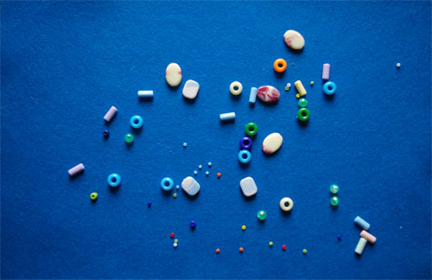
Fig. 1

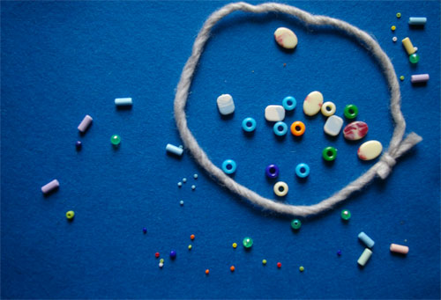
Fig. 2

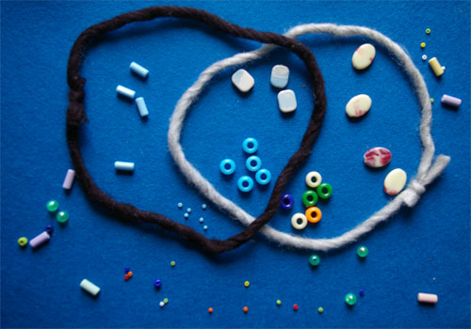
Fig. 3

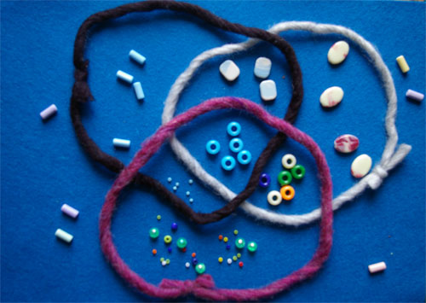
Fig. 4

